HELP MANUAL

WEB PORTAL

Campus Together

DHIRUBHAI AMBANI INSTITUTE OF INFORMATION AND
COMMUNICATION TECHNOLOGY (DA-IICT)

GETTING STARTED

1.1 Web Portal Manual

3.2.1 Logging in

To access ‘Campus Together’ web portal, each user should have a username and a password. The username would be their ID Number, provided by the institute (Identity cards) and the respective passwords used to login into Campus Intranet.

Step 1: Open any Browser installed on the Computer.
Step 2: Enter ‘Campus Together’ URL in the address bar and press ‘ENTER’
(Login Page would be displayed.)

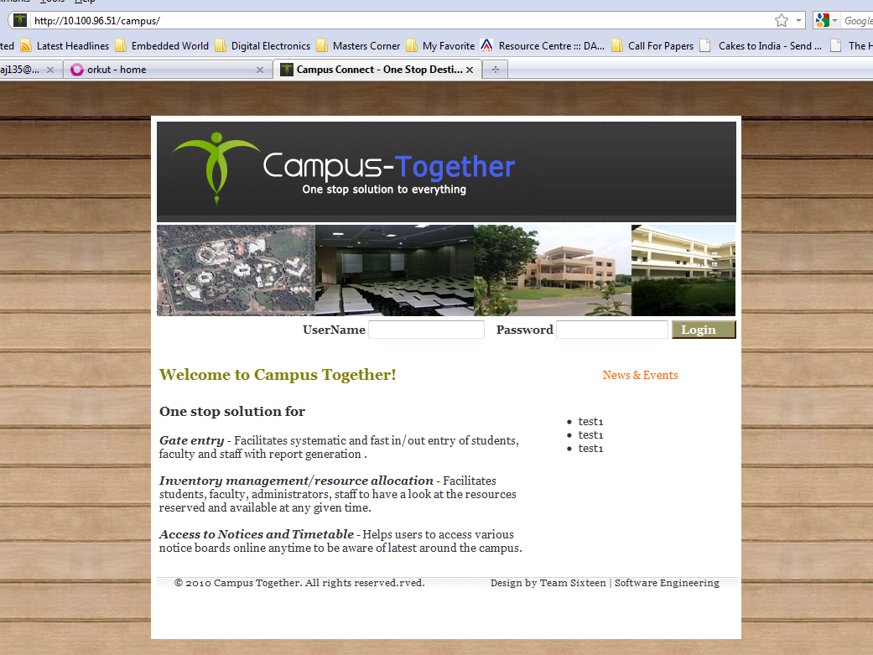
Step 3: Enter Username and Password, and Click on ‘Login’ Button.

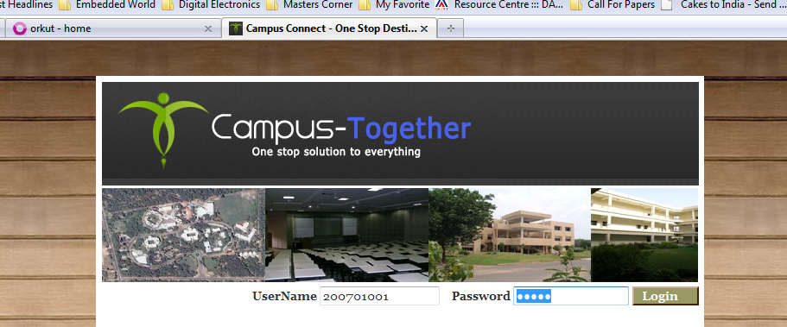

Step 4: If successful login, Home Page Would be displayed.

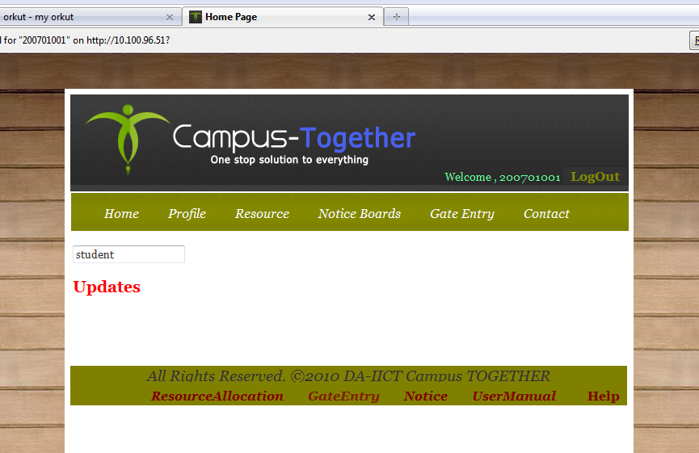

3.2.2 System Menu

3.2.2.1 Profile

3.2.2.1.1 View User Profile
Supported User Classes: All Users
Step 1: Click on ‘Profile’ tab on the navigation bar.

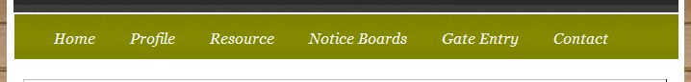

Your Profile will be displayed on the Web Page.

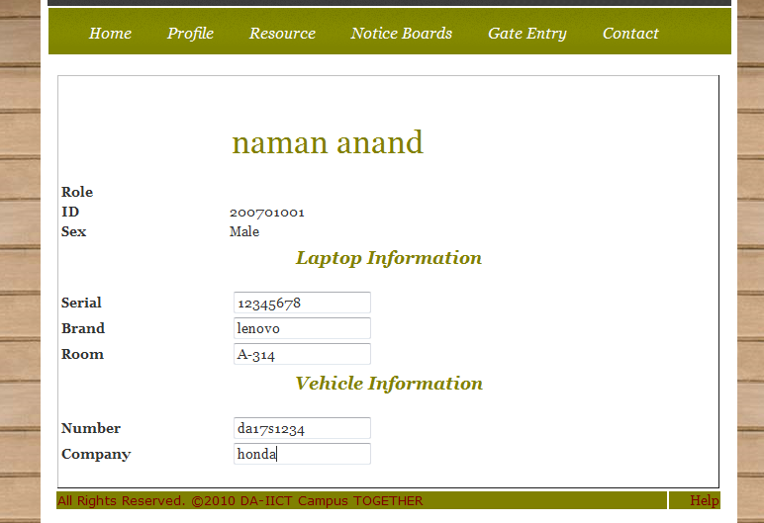

3.2.2.1.2 View Other User Profile
Supported User Classes: Admin, Faculty, Hostel Supervisor, Lab Resource
Allocator

Step 1: Click on ‘Profile’ tab on the navigation bar.

The Following information would be displayed.

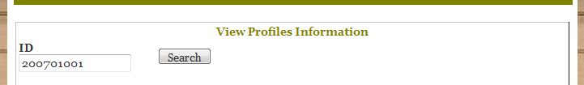

Step 2: Enter the Id of the person and Click on ‘Search’ Button.
The profile Information would be displayed.
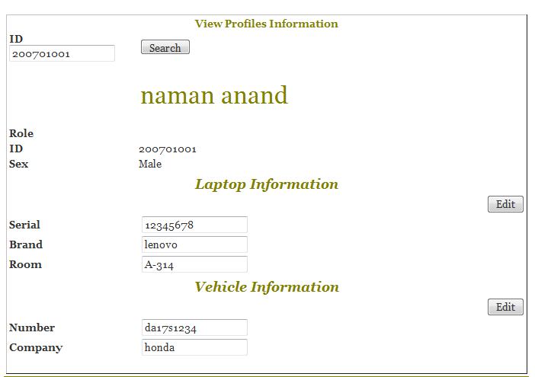

3.2.2.2 Request a Resource

3.2.2.2.1 Apply for the Issue of a Lab Resource
Supported User Classes: Student, Faculty

Step 1: Click on ‘Resource’ tab on the navigation bar.

Step 2: Click on ‘Lab Resources’ on the Sub-Navigation Menu.

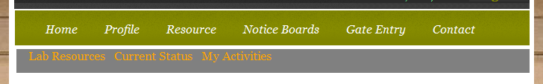

The List of all the available resources would appear.

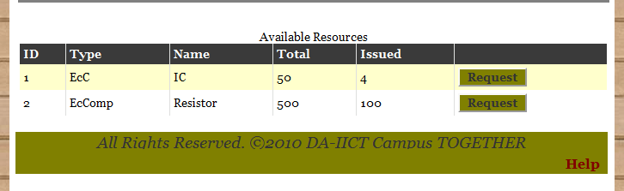

Step 3: Click on ‘Request’ Button at the end of each row in the table shown to request for the issue of that particular Resource.

A Request Form would appear on the Webpage.

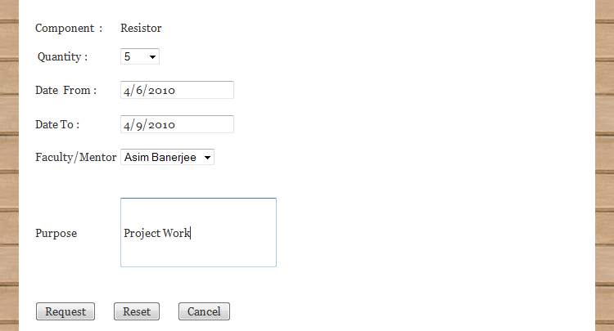

Step 4: Fill up the Above Form accordingly and
Click on ‘Request’ button for sending a request for the issue of the item.
Click on ‘Reset’ button to reset the filled form dat.
Click on ‘Cancel’ button to cancel the request.

A Notification would be generated for User information.

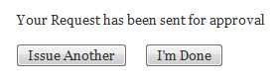
Step 5: Click on ‘I’m Done’ button to finish request for issue of a lab resource.
Click ‘Issue another’ button to request for other resource and follow all the steps
From 1 to 5.

3.2.2.2.2 Search for a Particular Resource by Name.
Supported User Classes: Student, Faculty

Step 1: Click on ‘Resource’ tab on the navigation bar.

Step 2: Click on ‘Lab Resources’ on the Sub-Navigation Menu.

The Following Search would appear on the page.

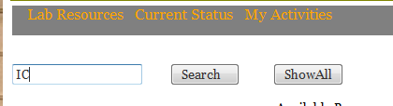

Step 3: Enter the name of the Resource and Click on ‘Search’ Button.

The Following information would appear based on your search word.

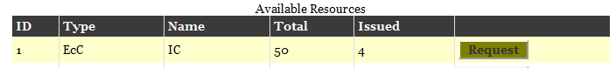

3.2.2.2.3 Status of Request

Step 1: Click on ‘Resource’ tab on the navigation bar.

Step 2: Click on ‘Current Status’ on the Sub-Navigation Menu.

All the Pending Status is tracked and a list of all requests would be available for the user.

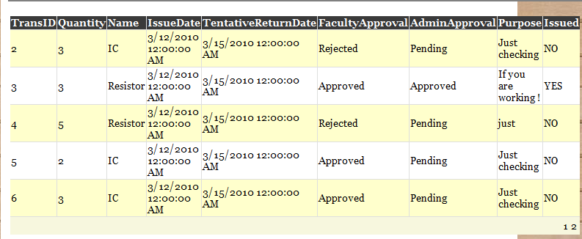

3.2.2.2.4 Viewing User Activity (Record of all Approved and issued Requests)

Step 1: Click on ‘Resource’ tab on the navigation bar.

Step 2: Click on ‘My Activities’ on the Sub-Navigation Menu.

(A Detailed view of all the Resource Requests would appear on the webpage.)

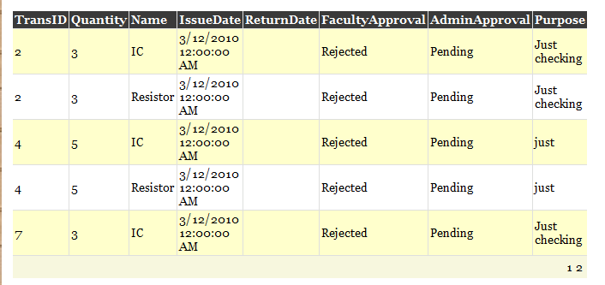
3.2.2.2.5 Apply for access into Lab/LT/CEP Room.
Supported User Classes: Faculty, Clubs/Committees

Step 1: Click on ‘Resource’ tab on the navigation bar.

Step 2: Click on ‘Rooms’ on the Sub-Navigation Menu.

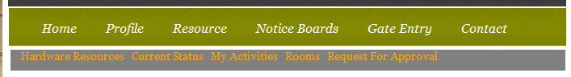

(The Following page would be displayed.)

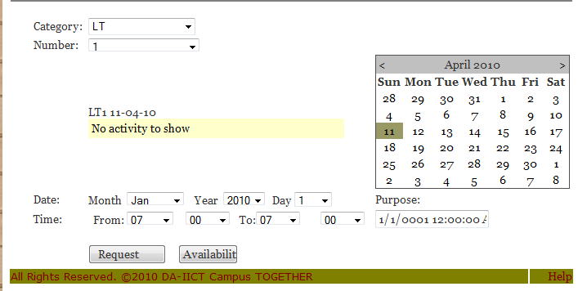

Step 2: Fill in the Details, as required in the form.
Click on ‘Availability’ Button to check for the availability of the Room.

Step 3: Click on ‘Request’ Button to request for the particular room.



3.2.2.2.6 Approve Student/Club/Committee Requests.
Supported User Classes: Faculty, Admin, Lab In charge, Lab Resource Allocator

Step 1: Click on ‘Resource’ tab on the navigation bar.

Step 2: Click on ‘Requests for Approval’ on the Sub-Navigation Menu.

(The Following page would be displayed.)
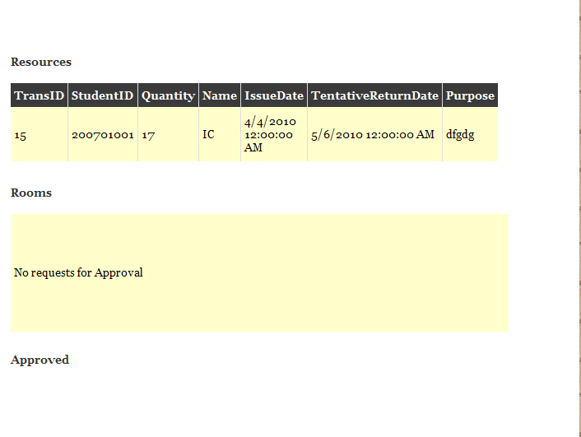

Step 3: Click on ‘Approve Request’ Button against each received requests to approve them.
3.2.2.2.7 Issue a Resource.
Supported User Classes: Lab Resource Allocator

Step 1: Click on ‘Resource’ tab on the navigation bar.

Step 2: Click on ‘Issue a Resource’ on the Sub-Navigation Menu.

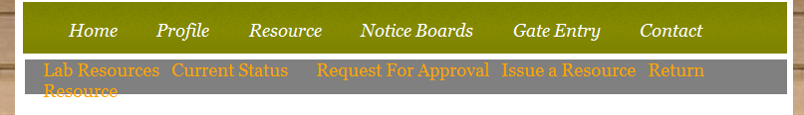

(The Following page would be displayed.)

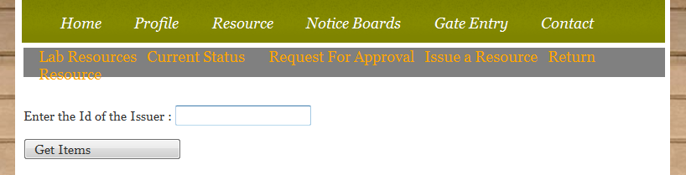

Step 3: Enter the User ID of the request Holder and Click on ‘Get Items’ button to get a list of items the user has requested for.

Step 4: Click on ‘Issue’ button against the request table displayed for issuing that particular item to the user.

3.2.2.2.8 Record Returning of an issued Resource.
Supported User Classes: Lab Resource Allocator

Step 1: Click on ‘Resource’ tab on the navigation bar.

Step 2: Click on ‘Return Resource’ on the Sub-Navigation Menu.

(The Following page would be displayed.)

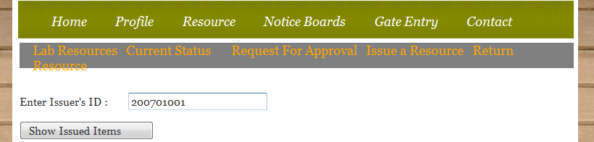

Step 3: Enter the User ID of the User and Click on ‘Show Issued Items’ button to get a list of items the user has been issued.

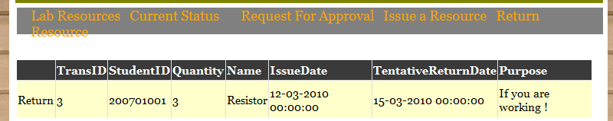

Step 4: Click on ‘Return’ button against the request table displayed above.
This finishes the process of returning a resource.

3.2.2.3 Notice Board

3.2.2.3.1 View and Manage Notice Board
Supported User Classes: Student, Faculty, Clubs/Committees

Step 1: Click on ‘Notice Boards’ tab on the navigation bar.

A list of all available Notice Boards would appear.
Each Notice Board will contain its respective Notices
(See Below)
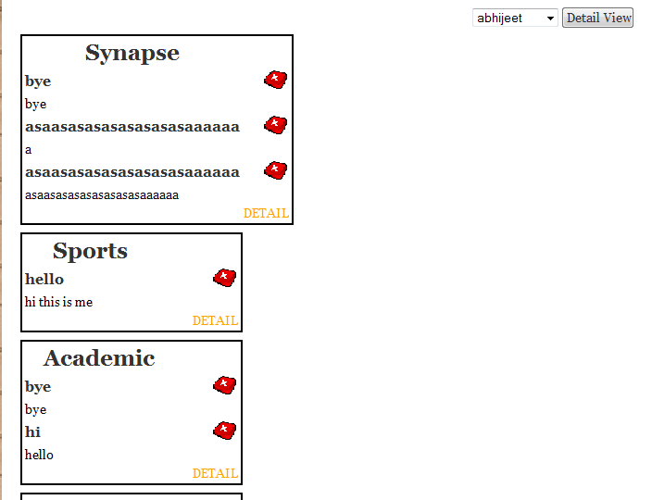

Step 2: Click on ‘RED CROSS’ icon appearing beside each Notice to Delete the Notice.

Step 3: Select a Notice Board from the Drop down Menu and Click on ‘DETAIL’ to view all the notices of that particular Notice Board in detail.

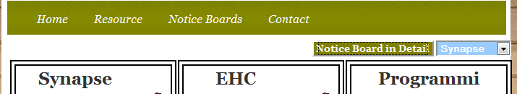

The Detailed View of Notice Board would Open Up.

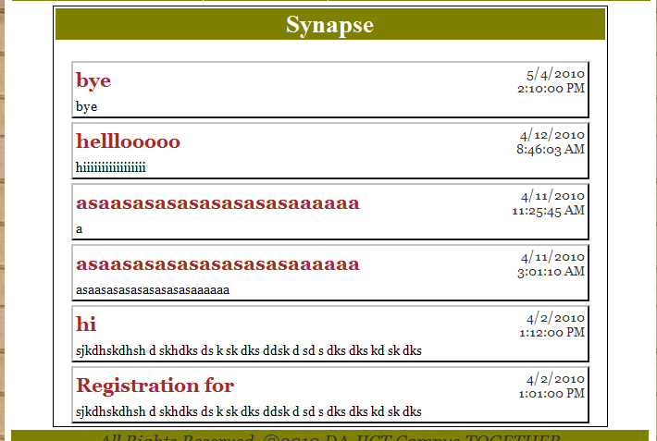

3.2.2.3.2 Post a Notice on the Notice Board
Supported User Classes: Clubs/Committees

Step 1: Click on ‘Notice Boards’ tab on the navigation bar.

The following Notice Boards would be available on the webpage.

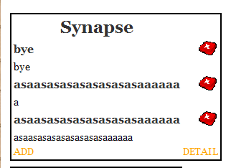

Step 2: Click on ‘ADD’ Button to add a New Notice.

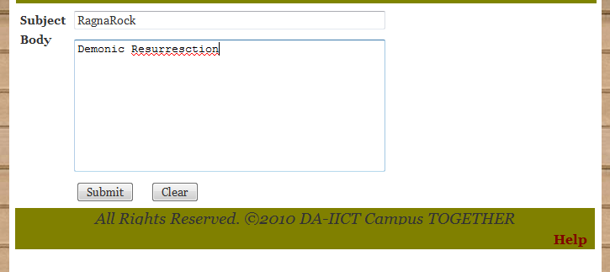

Step 3: Fill the Details as required and Click on ‘Submit’ Button.
The changes would be reflected in the Notice Board.
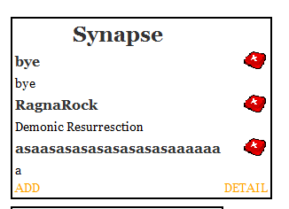

3.2.2.3.3 Remove a Notice on the Notice Board
Supported User Classes: Students, Faculty, Clubs/Committees

Step 1: Click on ‘Notice Boards’ tab on the navigation bar.

The following Notice Boards would be available on the webpage.

Step 2: Click on ‘RED CROSS’ Icon to remove a New Notice.

3.2.2.3.4 Add a NEW Notice Board on the list.
Supported User Classes: Admin

Step 1: Click on ‘Notice Boards’ tab on the navigation bar.

The following information would be available on the webpage.

Step 2: Click on ‘New Board’ to create a New Notice Board.

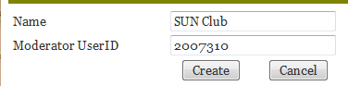

Step 3: Fill the details and Click on ‘Create’ to create a New Notice Board

3.2.2.3.5 DELETE a Notice Board on the list.
Supported User Classes: Admin

Step 1: Click on ‘Notice Boards’ tab on the navigation bar.

The following information would be available on the webpage.

Step 2: Click on ‘Delete Board’ to delete a New Notice Board.

3.2.2.4 Gate Entry Logs

3.2.2.4.1 View My IN/OUT Gate Entry Log.
Supported User Classes: Student, Faculty

Step 1: Click on ‘Gate Entry’ tab on the navigation bar.

A form as shown below will be displayed on webpage.

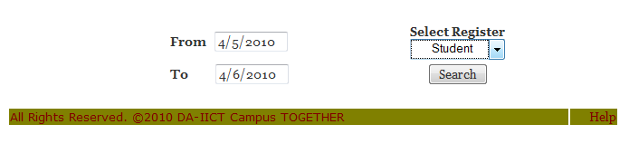
Step 2: Fill up the required fields appropriately and Click on ‘Search’ Button.

A Detailed table of the User IN/OUT entries at the Campus Gate would be displayed.

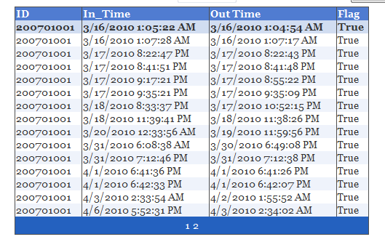

3.2.2.4.2 Register a Laptop
Supported User Classes: Hostel Supervisor

Step 1: Click on ‘Profile’ tab on the navigation bar.

The Following information would be displayed.

Step 2: Enter the Id of the person and Click on ‘Search’ Button.
The profile Information would be displayed.

Step 3: Click on ‘Edit’ Button behind the ‘Laptop Information’ section.
The following Information would be displayed

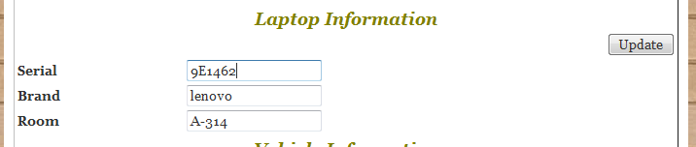

Step 4: Change/Update/Enter relevant Information in the Laptop information field and
Click on ‘Update’ Button behind the ‘Laptop Information’ section

The Laptop is registered.

3.2.2.4.3 Register a Student Vehicle
Supported User Classes: Hostel Supervisor

Step 1: Click on ‘Profile’ tab on the navigation bar.

The Following information would be displayed.

Step 2: Enter the Id of the person and Click on ‘Search’ Button.
The profile Information would be displayed.

Step 3: Click on ‘Edit’ Button behind the ‘Vehicle Information’ section.
The following Information would be displayed

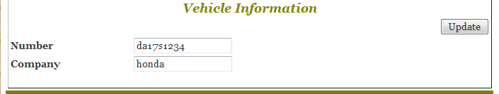

Step 4: Change/Update/Enter relevant Information in the Vehicle information field and
Click on ‘Update’ Button behind the ‘Vehicle Information’ section

The Vehicle is registered.

3.2.2.4.4 View a Users’ Gate Entry Log (Generate Reports)
Supported User Classes: Hostel Supervisor

Step 1: Click on ‘Gate Entry’ tab on the navigation bar.

The Following information would be displayed.

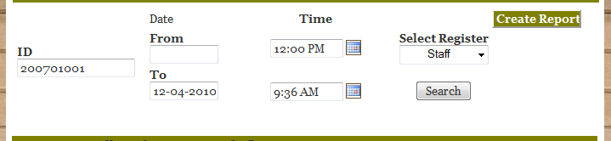

Step 2: Fill the ID of the person and other details as required in the field above.
Click on ‘Create Report’ Button behind the form.
The Following requested details would be generated on the page.
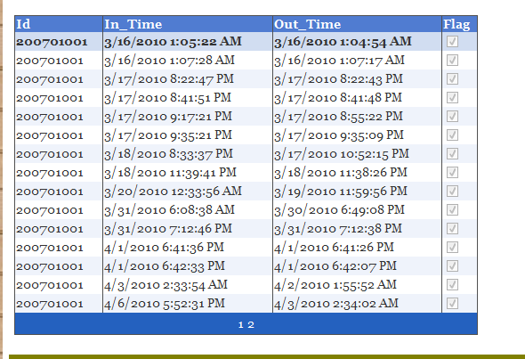

3.2.3 Help

Step 1: Click on ‘Help’ at the bottom of the webpage.

A Help Navigation Bar would appear at the bottom of the webpage.

Step 2: Click on ‘Notice’ for getting help for Notice Boards.

Step 3: Download the .pdf document and refer it for Help.

3.2.4 Logout

Step 1: Click on ‘Logout’ on the webpage
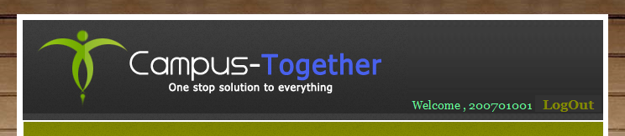

Step 2: You will be logged off and redirected to the Login Page.

----- 0 -----

